


重庆无界启航创新科技有限公司
Chongqing Infinite Horizons Co.Ltd 地址：重庆市渝北区龙兴镇卓越路21号附1号
邮箱：support@wujieqh.com
服务热线：19030916561
wwWwujieqh.com

触觉语音移动电源-XO
TactileVoice Power Bank-'XO'

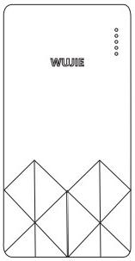

BPB-XO10000P20V
尊敬的用户，'XO'充电宝通过触觉和语音为您提供功能提示和电量 提示，为了您能够进一步了解产品，使用前请您自己阅读本说明书!

为产品充电

3DTMIN

≥PD 22.5W 1

提示：
首次使用前请为产品充满电；为提高充电效率，建议使 用PD22.5W 以上的充电器。

为您的设备充电

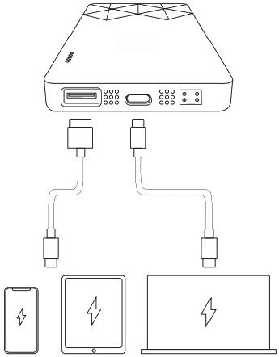

3DTnN

接入设备后，您的设备将自动开始充电。如连接后无法 充电，请再次插拔。

按键操作
单击按键：电量提示。
双击按键：紧急静音。
长按按键：模式切换。(长按3秒，语音、触点、双模，三种 模式切换)
当单击按键时
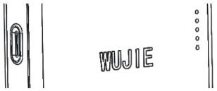
电量提示分为三种模式：
1.仅语音提示：当前电量剩余'xx’。


门
2.仅触觉提示：触觉模组凸点升起，凸起4个凸点代表剩 余电量为75%-100%。

 | 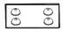 | 000  000  000

3.凸起3个凸点代表剩余电量为50%-75%。
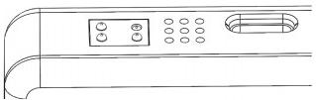
4.凸起2个凸点代表剩余电量为25%-50%。
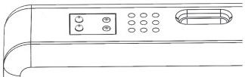
5.凸起1个凸点代表剩余电量为0-25%。
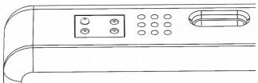
语音+触觉提示
结合以上两者
其他语音提示
充电提示：当给本充电宝充电时，语音播报“开始充电”; 充电时短按按键进入电量查询，语音提示“充电到‘xx'; 充满电后，语音提示5次“电量已满”,或者单击按键时， 提示“电量已满”。

放电提示：当本充电宝给其他设备充电时，语音提示“开 始放电”。
电量低于5%时，语音提示“电量不足，请及时充电”。 功率分配
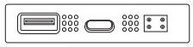
C口充电电流：5V3A/9V/2A
C口放电电流：5V3A/9V2.22A/12V/1.67A
A口输出：5V3A/9V2.2A/12V/1.67A
产品参数

产品型号 | BPB-C10000P20V
电芯容量 | 10000mAh
电池类型 | 锂离子电池
额定容量 | 6500mAh
输入 | Type-C:5V3A/9V/2A
输入 | USB:5V3A/9V2.2A/12V1.67A
输出 | Type-C:5V3A/9V2.22A/12V1.67A
注意事项
1.充电过程中若发现充电宝发烫、异味、鼓包等异常情 况，需立即断开电源，停止使用，并联系售后处理。

2.设备耐摔范围仅限1.5m 高度，请勿超出该范围跌落 或遭受剧烈撞击，外观开裂、损坏或鼓包严禁使用!
3.充电时需使用合规的数据线与电源适配器，避免使用 劣质配件导致设备故障或安全风险。
4.长期不使用设备时，建议保持30%-60%电量存放，并 定期(如每1个月)补电一次，以保护电芯寿命。
5.避免在高温(>40℃)、潮湿(相对湿度>80%)环境下 使用或存放，远离火源、腐蚀性物质，防止设备损坏。
6.部分设备(如部分相机、游戏机)可能因接口协议不兼 容无法充电，建议使用原装充电线尝试。
7.快充功能需搭配支持对应快充协议的设备及充电线 使用，否则仅能实现普通充电。
售后服务
1.本产品自购买之日起，享受6个月质保服务。在质保期 内，因产品本身质量问题导致的故障，可凭购买凭证享 受免费维修或更换服务。
2. 以下情况不在质保范围内：人为损坏(如摔落、拆解、 挤压)、使用非标配配件导致的故障、因不可抗力(如火 灾、水灾)造成的损坏。
3.售后请联系客服，官网：www.wujieqh.com
温馨提示：本产品内置锂离子电池，请勿随意丢弃，废弃 时请交由专业回收机构处理，避免环境污染。

Recharging Your Power Bank

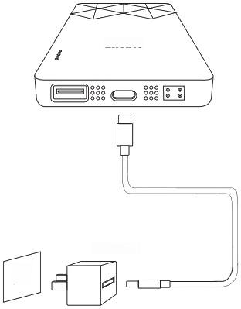

3DrMIN

≥PD 22.5W
1

Tips:
Fully charge the product before first use;To enhance charging efficiency,it is recommended to use a PD 2.5W or higher charger.

Charge your device

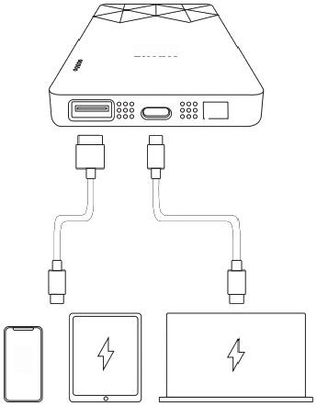
3DrN

88

个

After access devices,your device will automatically start charging.If it cannot be charged,please plug and unplug it again.

Key operation
Click the button:Battery level prompt.
Double-click the button:Emergency mute.
Long press:Mode switch.(Long press 3 seconds, voice,contact,dual mode,three modes switch)
When the button is clicked
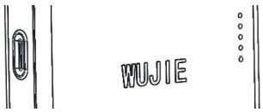
Power tip is divided into three patterns:
1.Voice prompt only:current power remaining'xx'

◎ ◎
◎ ◎

2.Note:only touch touch module rises bumps and raised 4 bumps on behalf of the remaining power of 75%to 100%.
000
0 0 0
8
000

3.The raised three bumps on behalf of the remaining power of 50%to 75%.
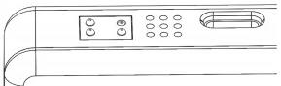
4.A raised two bumps on behalf of the remaining power of 25%to 50%.
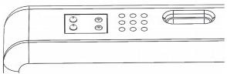
5.A bump represents a residual charge of 0-25%
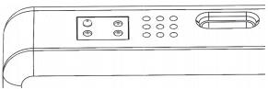
Voice +tactile prompt
Combine the above two.
Other voice prompts
Charging tip:when recharge the charging treasure, speech "start charging";When charging,tap the button to enter the power query,and the voice prompt "Charge to 'xx';After a full charge,voice prompts "full power"five times,or "full power"when a key is clicked.

Discharge tip:when the charging treasure to other devices,voice prompt "began to discharge.Power is lower than 5%,the voice prompt "power is insuffi- cient,please recharge in time.
Power distribution
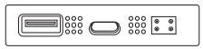
Charging current at port C:5V3A/9V/2A
Discharge current at port C:5V3A/9V2.22A/12V/1.67A Output from Port A:5V3A/9V2.2A/12V/1.67A
Product parameters

Product model | BPB-C10000P20V
CellCapacity | 10000mAh
Battery type | Lithium-ion battery
Rated Capacity | 6500mAh
Input | Type-C:5V3A/9V/2A
Input | USB:5V3A/9V2.2A/12V1.67A
Output | Type-C:5V3A/9V2.22A/12V1.67A
Precautions

1.If you find that the powerbank is hot,smelly,or bulging during charging,disconnect the power supply immediately,stop using it,and contact the after-sales service.
2.The fall resistance range of the equipment is only 1.5m high.Do not fallor suffer severe impact outside the range.Cracked,damaged or bulging is strictly prohibited!
3.Use compliant data cable and poweradapter when charging to avoid equipment failure or safety risk caused by inferior accessories.
4.The equipment is not used for a long time,suggest 30%60%electricity storage,and periodically(e.g., every 1 months)electricity once,in order to protect the batteries life.
5.Avoid using or storing in high-temperature(>40℃) and humid (relative humidity>80%)environments. Keep away from fire sources and corrosive substanc- es to prevent equipment damage.
6.Some devices (such as some cameras and game consoles)may not be able to charge due to incom- patible interface protocols.It is recommended to try using the original charging cable.

7.Quick charge function need to match the support equipment and corresponding quick charge agreement charging line is used,otherwise can only achieve normal charge.
After-sales service
1.The product is guaranteed for 6 months from the date of purchase.In the warranty period,because of the product itself quality problem caused by fault, but by buying vouchers for free repairor replacement service.
2.The following conditions are not covered by the warranty:man-made damage(such as falling, dismantling,extrusion),failure caused by the use of non-standard parts,damage caused by force majeure(such as fire,flood).
3.After,please contact customer service website: www.wujieqh.com
Tip:This product has a built-in lithium-ion battery.Do not discard itat will.Please submit itto aprofessional recycling agency to dispose of it to avoid environ- mental pollution.

产品保修卡

感谢您购买无界启航的产品，为了更好的为您 服务，请您根据实际情况填写产品保修卡，谢谢!

_年 月 日

产品型号： 用户姓名：

产品名称： 联系电话：

购买日期：_ 电子邮箱：

用户地址：

售后附言：



公司名称：重庆无界启航创新科技有限公司
地址：重庆市渝北区龙兴镇卓越路21号附1号

